ASSIGNMENT-4

DISTANCEDETECTIONUSINGULTRASONICSENSOR

|  |  |
| --- | --- |
| Date | 20October2022 |
| TeamID | PNT2022TMID10953 |
| Name | ABISHEK B |
| StudentRollNumber | 811519106003 |
| MaximumMarks | 2Marks |

# Question1:

Writecodeandconnectionsinwokwiforultrasonicsensor.Wheneverdistanceislessthan100cmssend"alert"toibmcloudanddisplayindevicerecentevents.

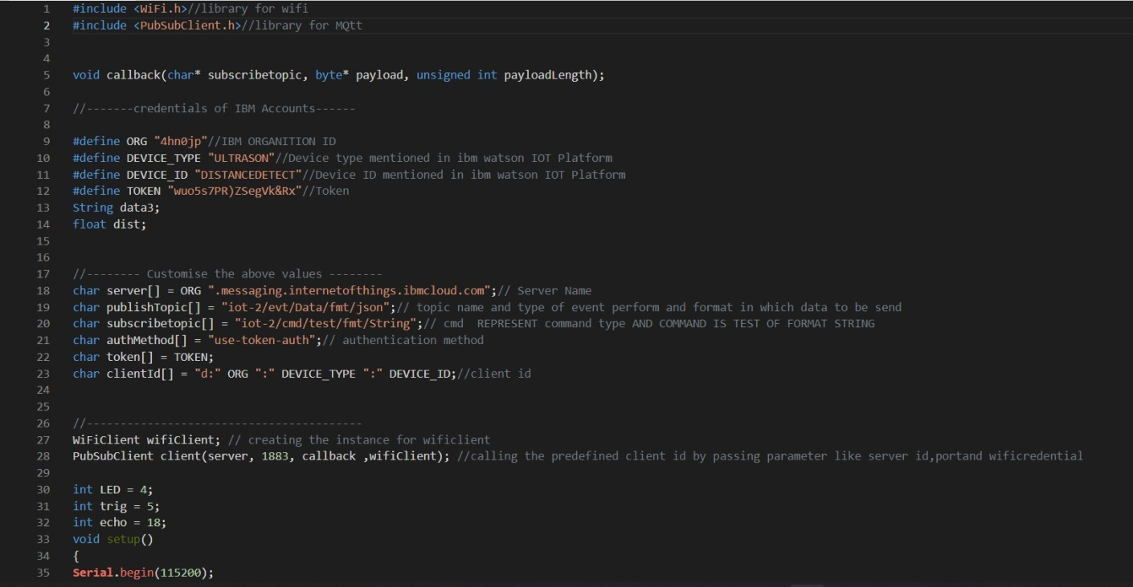CODE:

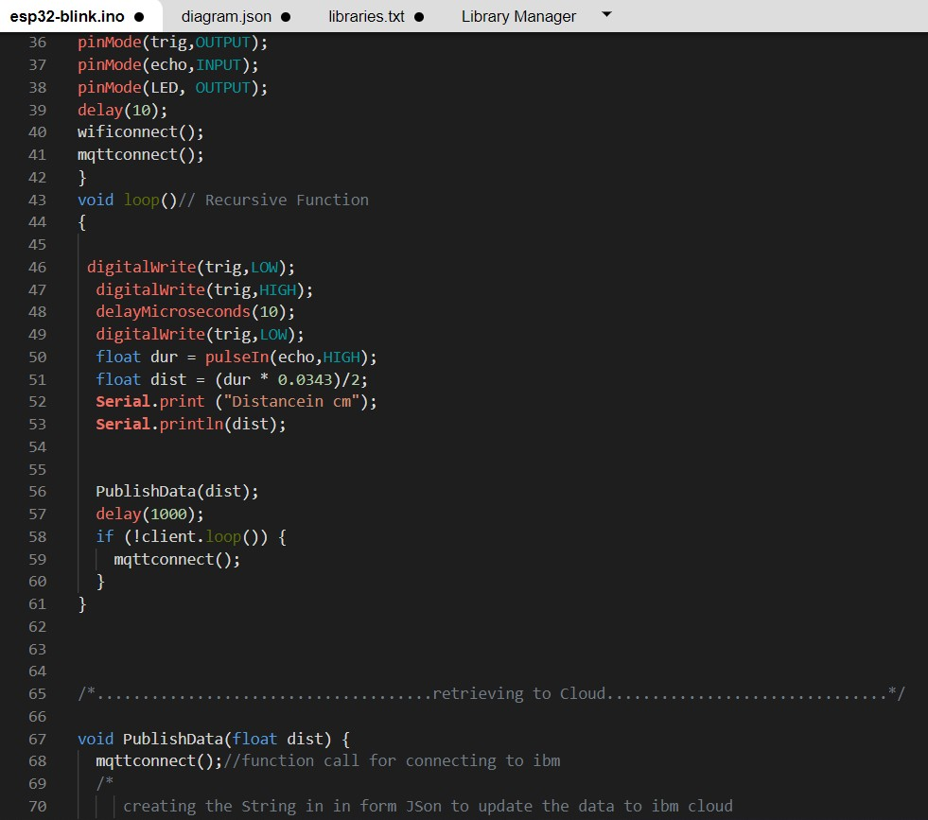

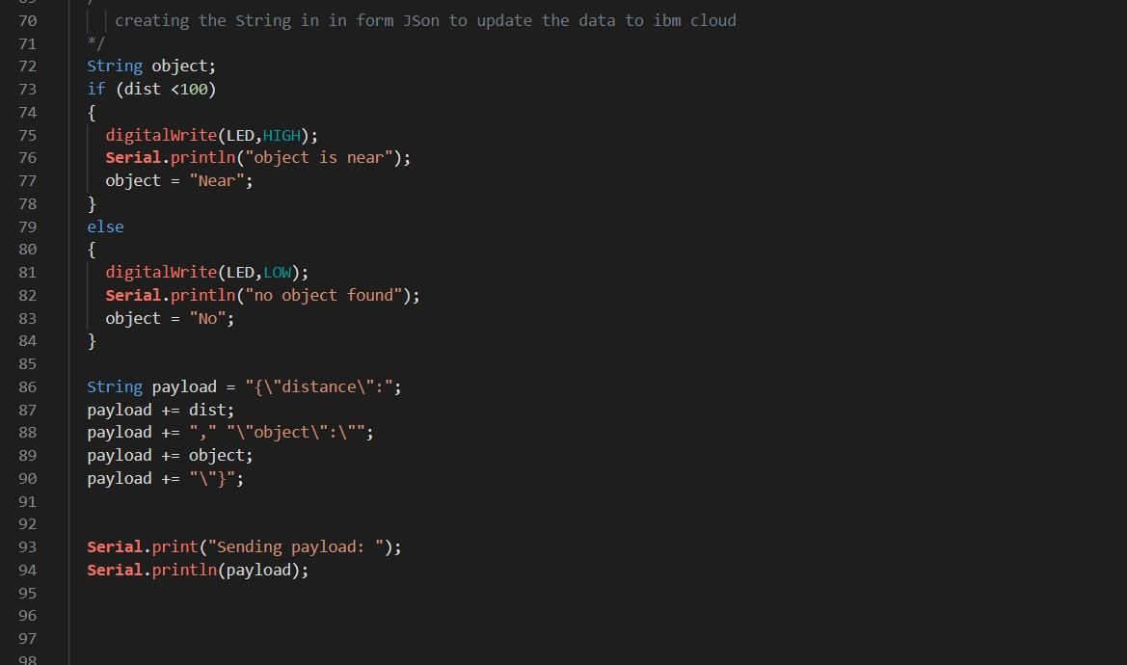

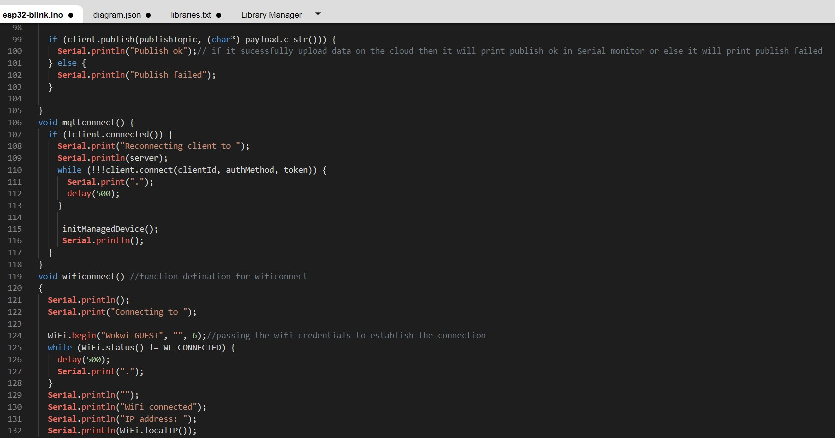

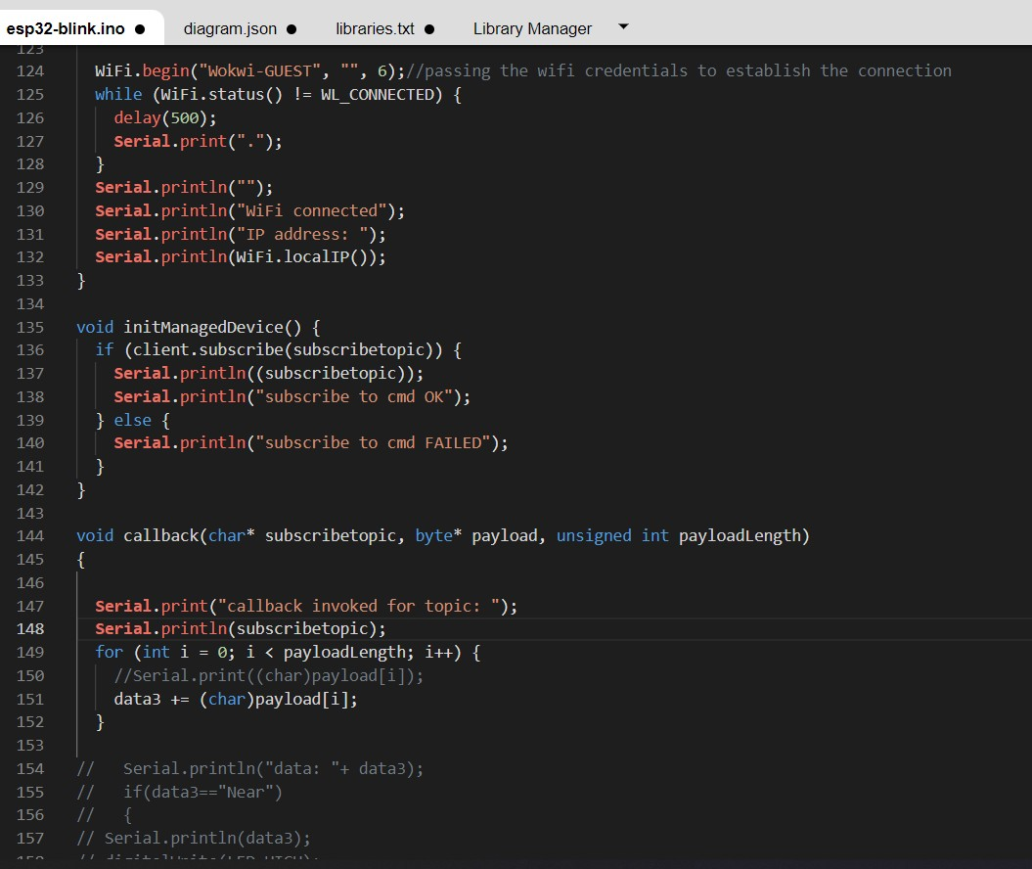

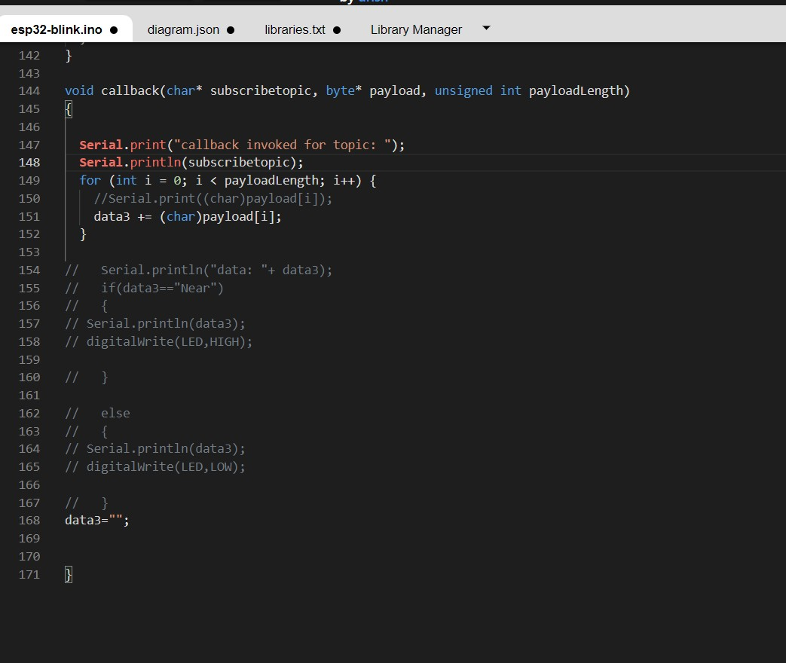

# OUTPUT:

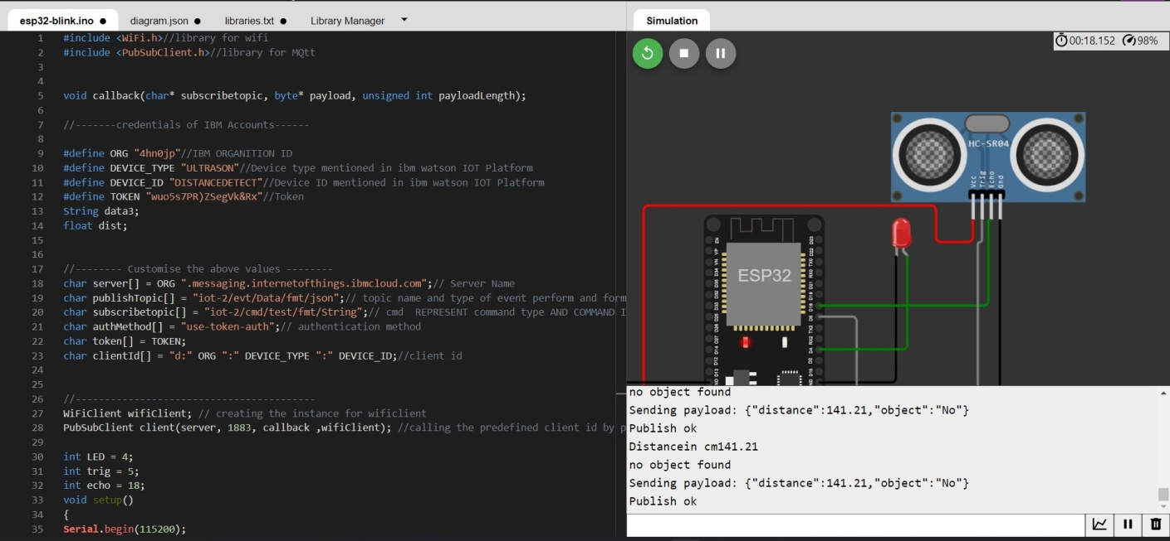

DatasendtotheIBMclouddevicewhentheobjectisfar

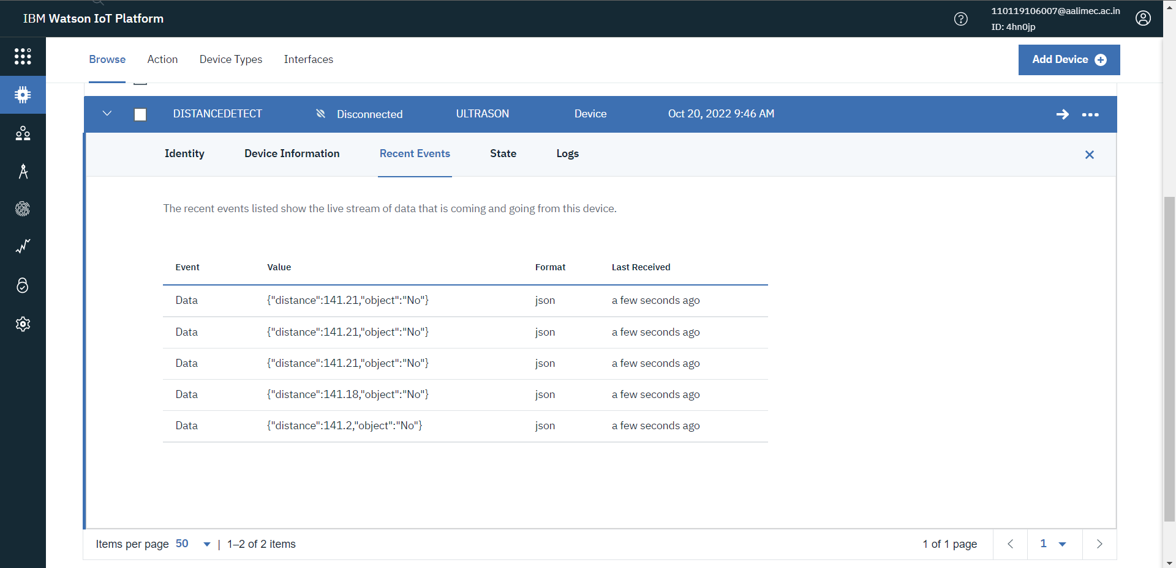

# whenobjectisneartotheultrasonicsensor

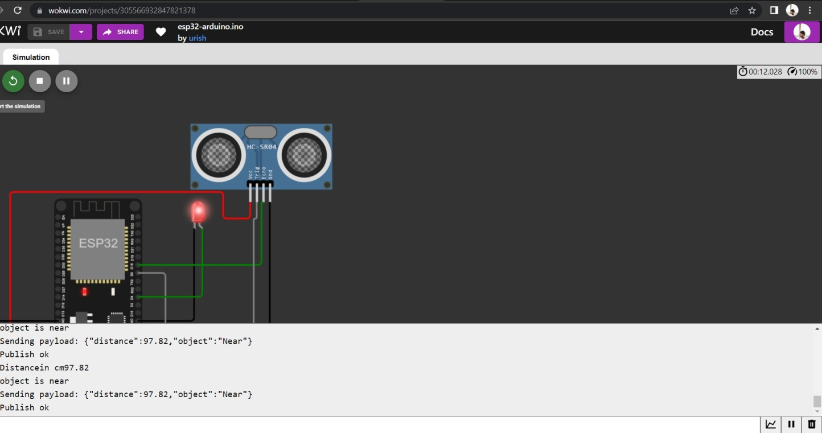

DatasenttotheIBMCloudDevicewhentheobjectisnear

